SendGrid Email Step

Objective

SendGrid is a cloud-based SMTP provider that allows you to send email without having to maintain email servers. SendGrid manages all of the technical details, from scaling the infrastructure to ISP outreach and reputation monitoring to whitelist services and real-time analytics.

UI

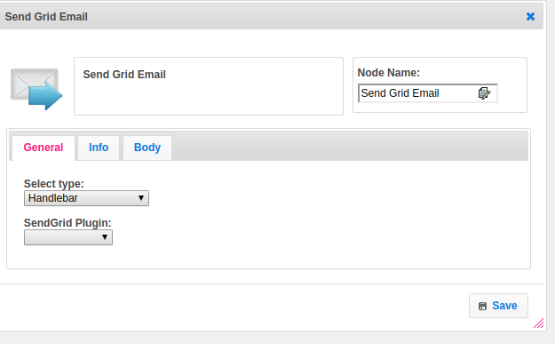

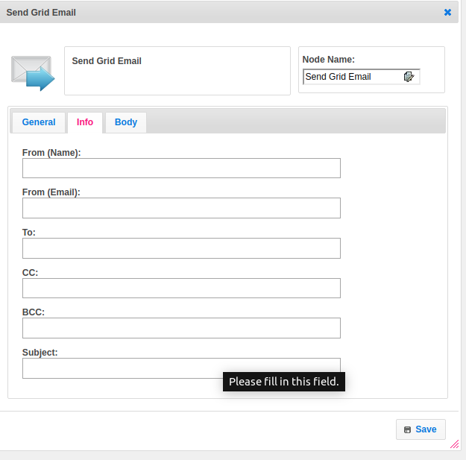

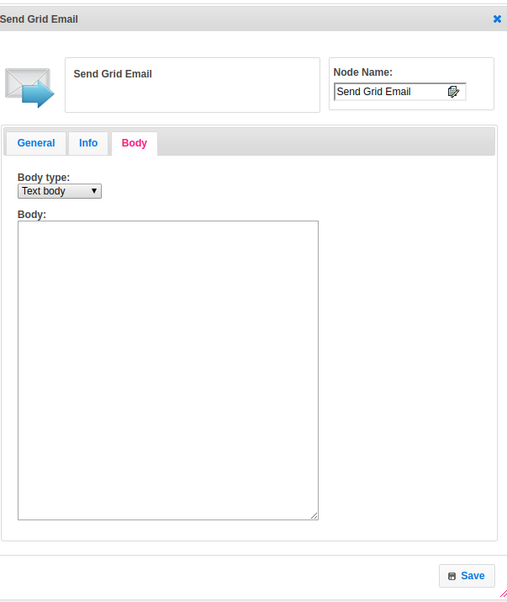

## 

## Attributes

|  |  |
| --- | --- |
| **Attributes** | **Description** |
| **1. Select Type** | Select Type used to set the value type.  Value types are two types.  1.hb-HandleBars  2.ftl-Freemarker Template Language. |
| **2. Plugin Name** | Name of the plugin. It contains the plugin configuration information. To get more information about plugin please refer the Plugin Dependence block. |
| **3. From name** | Name of the sender. |
| **4. From mail** | From mail address. |
| **5. To** | To mail address. |
| **6. CC** | CC(Carbon Copy ) mails. |
| **7. BCC** | BCC(Blind Carbon Copy ) mails. |
| **8. Subject** | The subject represents the mail subject |
| **9. Body type** | Body_type is having the type of body.  Supports two types of data  1.text/plain  2.text/HTML |
| **10. Body** | In the body, we can pass body data. |

## Execution Description:

Get the SendGrid plugin information from the context object. Call the SendEmail method by passing the from email, from-name, to email, cc email, bcc email, subject, body type, and body.If response.getStatuscode is equal to 202 then Your message is both valid and queued to be delivered.

## Plugin Dependencies:

|  |  |
| --- | --- |
| **Attributes** | **Description** |
| **1. Plugin Config Name** | Name of the plugin |
| **2. API Key** | This endpoint allows you to retrieve all API Keys that belong to the authenticated user.  The API Keys feature allows customers to be able to generate an API Key credential which can be used for authentication with the SendGrid v3 Web API. |

## Resource:

Please find the below link to get more information.

<https://sendgrid.com/docs/api-reference/>